Project Report Format

# 1. INTRODUCTION

## 1.1 Project Overview

The project titled **"Measuring the Pulse of Prosperity: An Index of Economic Freedom"** aims to analyze and visualize the economic conditions of regions or countries using key indicators that reflect the degree of economic freedom. Economic freedom is a critical factor influencing the prosperity, growth, and well-being of a population. This project leverages data analytics and visualization tools to build a comprehensive index that captures various dimensions such as government integrity, business freedom, fiscal health, property rights, and trade openness. By aggregating these factors, the project offers an insightful perspective into how economic freedom correlates with development, investment potential, and quality of life.

## 1.2 Purpose

The purpose of this project is to:

* Develop an **interactive economic freedom index** based on multiple indicators.
* **Visualize disparities and trends** in economic freedom across regions or countries.
* Provide **data-driven insights** to policymakers, investors, and researchers to understand how freedom in the economic environment affects national prosperity.
* Support **evidence-based decision-making** by showcasing patterns, challenges, and opportunities through intuitive dashboards and analytical reports.
* Foster awareness and stimulate discussions on how improving economic freedom can lead to sustainable development and inclusive growth.

# 2. IDEATION PHASE

## 2.1 Problem Statement

Despite the growing recognition that economic freedom plays a vital role in national development and prosperity, many regions lack a clear, data-driven understanding of how various economic factors influence growth and well-being. Existing indices may not fully capture the nuanced differences across regions or provide an accessible way to explore trends and impacts over time.

There is a need for an integrated platform that consolidates diverse economic indicators into a unified index, enabling policymakers, economists, investors, and citizens to assess and compare the economic freedom of regions. Without such a tool, decision-making may be based on incomplete data, resulting in inefficient policy formulation, investment strategies, or development planning.

This project aims to bridge that gap by building a visual, data-centric index that not only measures economic freedom but also illustrates its direct correlation with prosperity metrics.

## 2.2 Empathy Map Canvas

**Empathy Map Canvas:**

**Empathy Map for "Measuring the pulse of prosperity: an index of economic freedom analysis"**

User/Stakeholder (Central Figure): Consider who your primary user is for this analysis. This could be a policymaker, an economist, a student researcher, an investor, or even an interested citizen. For this example, let's consider a Policymaker.

**What does the Policymaker THINK AND FEEL?**

* What really counts: Ensuring national economic growth and stability. Understanding how policy decisions impact economic freedom.
* Major preoccupations: Balancing regulations with market efficiency. Attracting foreign investment. Addressing social welfare while promoting economic liberty.
* Worries & aspirations: Fear of unintended consequences from policy changes. Aspiration to implement effective policies that lead to prosperity and improved living standards.

**What does the Policymaker HEAR?**

* What friends say: Colleagues discussing the latest economic data and policy debates.
* What boss say: Directives and mandates from higher authorities regarding economic targets and reforms.
* What influencers say: Reports and analyses from think tanks, international organizations (e.g., World Bank, IMF), and academic experts on economic freedom and its effects. Lobbyists from various industries advocating for their interests.

**What does the Policymaker SEE?**

* Environment: News reports on economic indicators (GDP, inflation, unemployment). Public discourse on economic policies. International rankings and comparisons of economic freedom.
* Friends: Other policymakers, advisors, and economists.
* What the market offers: Various economic models, data analytics tools, and policy recommendations from different sources.

**What does the Policymaker SAY AND DO?**

* Attitude in public: Expressing commitment to economic growth and development. Discussing the importance of sound economic principles.
* Appearance: Professional and informed.
* Behaviour towards others: Engaging in policy debates. Commissioning research. Attending conferences and workshops on economic policy. Drafting or proposing legislation related to economic reforms.

**Pain:**

* Fears: Misinterpreting economic data. Implementing policies that stifle growth or lead to public discontent. Being blamed for economic downturns.
* Frustrations: Difficulty in finding clear, actionable insights from complex economic data. Resistance to reform from vested interests. Slow pace of legislative processes.
* Obstacles: Lack of comprehensive data. Conflicting advice from experts. Political constraints and public opinion.

**Gain**:

* "Wants"/needs: Clear, concise analysis of the economic freedom index. Actionable recommendations for policy adjustments. Evidence-based support for policy decisions.
* Measures of success: Improved economic freedom rankings for the country. Sustainable economic growth. Increased foreign direct investment. Positive public perception of economic policies.
* Obstacles (overcoming them): Utilizing the economic freedom index as a robust tool for policy design and justification, providing a clear framework for understanding and addressing economic challenges.

## 2.3 Brainstorming

**Brainstorm & Idea Prioritization Template:**

Brainstorming provides a free and open environment that encourages everyone within a team to participate in the creative thinking process that leads to problem solving. Prioritizing volume over value, out-of-the-box ideas are welcome and built upon, and all participants are encouraged to collaborate, helping each other develop a rich amount of creative solutions.

Use this template in your own brainstorming sessions so your team can unleash their imagination and start shaping concepts even if you're not sitting in the same room.

Reference: <https://www.mural.co/templates/brainstorm-and-idea-prioritization>

**Step-1: Team Gathering, Collaboration and Select the Problem Statement**

**Problem Statement Selected:**  
How can we develop a comprehensive and accurate index that measures economic freedom across different regions or countries, in order to assess and compare their economic health and development?

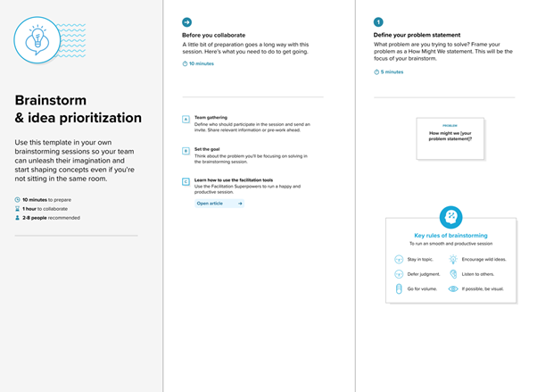

**Step-2: Brainstorm, Idea Listing and Grouping**

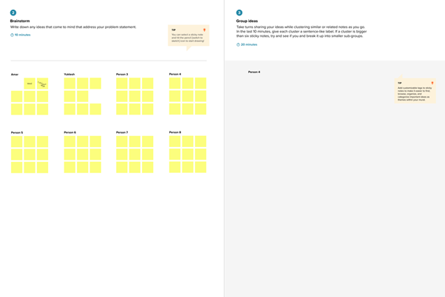

**Brainstormed Ideas:**

1. Use global indices like Heritage Foundation and Fraser Institute as baseline references.
2. Collect data on key economic indicators: trade freedom, fiscal health, government integrity, property rights, etc.
3. Apply data normalization and scoring techniques for uniformity.
4. Group countries into tiers based on economic freedom scores.
5. Use Tableau for interactive data visualization and storytelling.
6. Compare historical trends and predict future improvements.
7. Create a dashboard ranking countries/states by index score.
8. Include public policy suggestions based on findings.

**Grouped Under Categories:**

* **Data Collection: 1, 2**
* **Data Processing & Analysis: 3, 4, 6**
* **Visualization & Reporting: 5, 7**
* **Insights & Recommendations: 8**

**Step-3: Idea Prioritization**

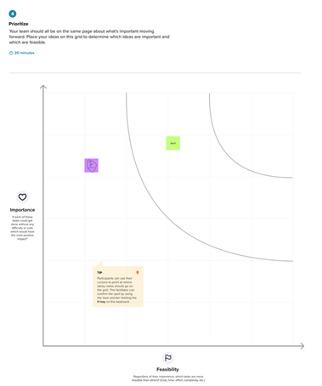

| **Idea** | **Priority (High/Medium/Low)** | **Reason** |
| --- | --- | --- |
| Use global indices as reference | High | Reliable benchmarks to start with |
| Collect key economic indicators | High | Core data requirement |
| Normalize and score data | High | Ensures comparability |
| Group countries by score | Medium | Helps categorize insights |
| Use Tableau for visualization | High | Clear presentation and storytelling |
| Predict future trends | Medium | Adds insight but requires models |
| Create dashboard | High | Easy interpretation of results |
| Policy suggestions | Medium | Valuable but beyond scope if limited on time |

# 3. REQUIREMENT ANALYSIS

## 3.1 Customer Journey Map

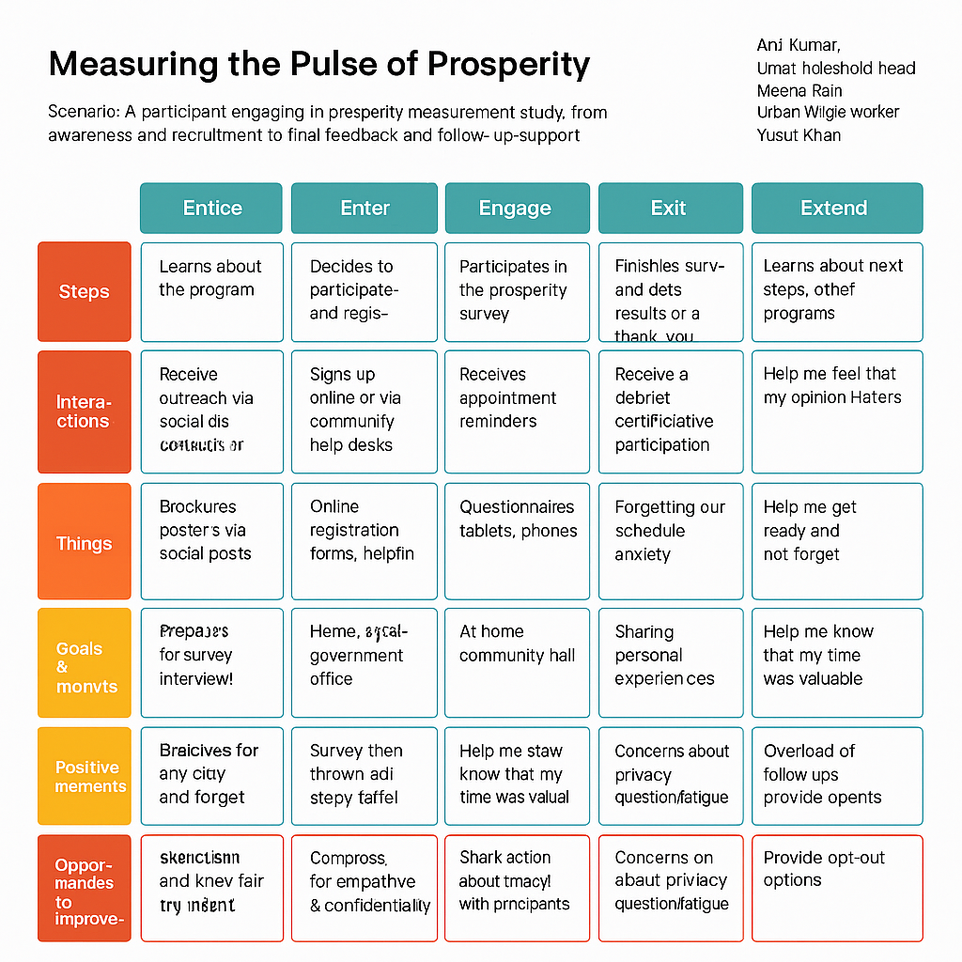

## 3.2 Solution Requirement

**Functional Requirements:**

Following are the functional requirements of the proposed solution.

|  |  |  |
| --- | --- | --- |
| **FR No.** | **Functional Requirement (Epic)** | **Sub Requirement (Story / Sub-Task)** |
| FR-1 | Data Upload | Upload Economic Freedom Index CSV files Upload GDP and HDI datasets |
| FR-2 | Data Preprocessing | Data cleaning and formatting using Python Handling missing or null values |
| FR-3 | Visualization | Create country-wise comparative dashboards Implement correlation visualizations between freedom & GDP Add dynamic filters for year, region, and economic tier |
| FR-4 | Insight Extraction | Identify top/bottom performing nations Show pattern-based insights via story dashboards |
| FR-5 | Export Options | Export dashboards to PDF or PNG Allow download of filtered datasets |

**Non-functional Requirements:**

Following are the non-functional requirements of the proposed solution.

|  |  |  |
| --- | --- | --- |
| FR No. | Non-Functional Requirement | Description |
| NFR-1 | Usability | Dashboards should be intuitive and easy to interpret for all stakeholders |
| NFR-2 | Security | File upload/download permissions, view-only access on dashboards |
| NFR-3 | Reliability | Data visualizations should render correctly across all filters |
| NFR-4 | Performance | Dashboards should load within 3 seconds on average |
| NFR-5 | Availability | Published dashboards must be accessible 24/7 |
| NFR-6 | Scalability | New datasets should be easily ingestible without structural changes |

## 3.3 Data Flow Diagram

**Data Flow Diagrams:**

A Data Flow Diagram (DFD) is a traditional visual representation of the information flows within a system. A neat and clear DFD can depict the right amount of the system requirement graphically. It shows how data enters and leaves the system, what changes the information, and where data is stored.

**Example:** [**(Simplified)**](https://developer.ibm.com/patterns/visualize-unstructured-text/)

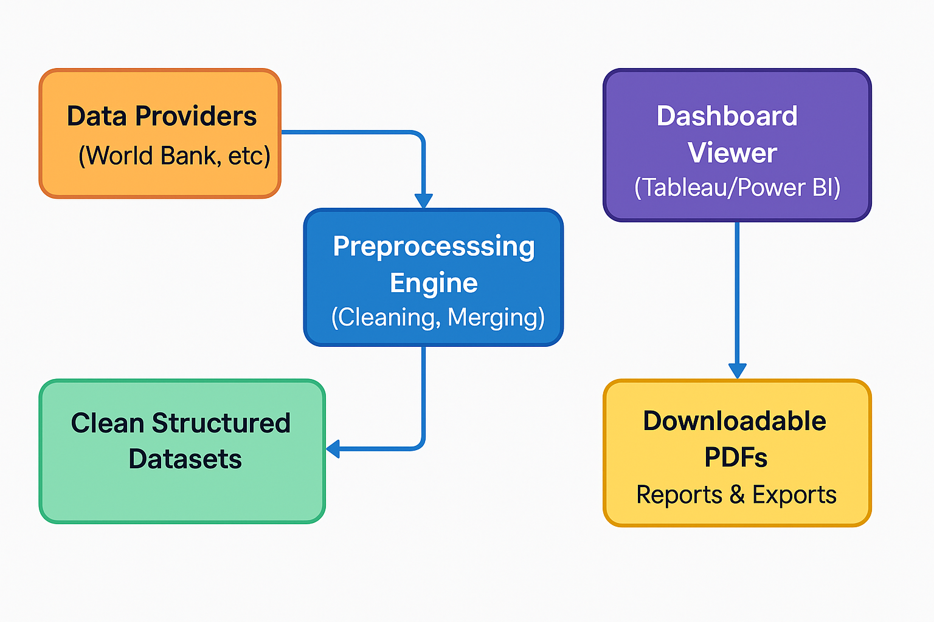

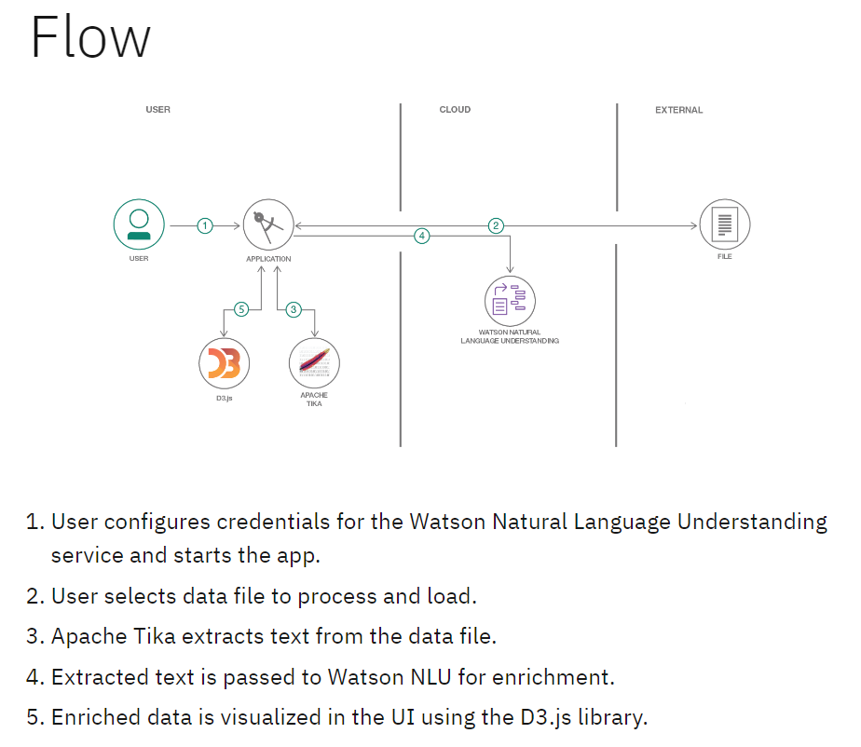

**User Stories**

Use the below template to list all the user stories for the product.

|  |  |  |  |  |  |
| --- | --- | --- | --- | --- | --- |
| **User Type** | **Functional Requirement (Epic)** | **User Story Number** | **User Story / Task** | **Acceptance Criteria** | **Priority / Release** |
| Research Analyst | Data Upload | USN-1 | Upload Economic Freedom Index and GDP datasets | Files upload successfully and appear in dataset list | High / Sprint-1 |
| Research Analyst | Data Preprocessing | USN-2 | Clean and merge uploaded datasets | Cleaned dataset is preview able with no missing values | High / Sprint-1 |
| Research Analyst | Visualization Setup | USN-3 | Visualize country-wise freedom scores | Charts render for each selected region | High / Sprint-2 |
| Research Analyst | Comparative Analysis | USN-4 | Correlate freedom index with GDP/HDI | Correlation graphs display accurately | Medium / Sprint-2 |
| Research Analyst | Filtering & Interaction | USN-5 | Filter data by year or region | Filters work and update views immediately | High / Sprint-2 |
| Research Analyst | Export | USN-6 | Export dashboard views to PDF | Download includes current view and filter | Medium / Sprint-3 |

## 3.4 Technology Stack

**Technical Architecture:**

The Deliverable shall include the architectural diagram as below and the information as per the table1 & table 2

**Example: Order processing during pandemics for offline mode**

**Reference:** [**https://developer.ibm.com/patterns/ai-powered-backend-system-for-order-processing-during-pandemics/**](https://developer.ibm.com/patterns/ai-powered-backend-system-for-order-processing-during-pandemics/)

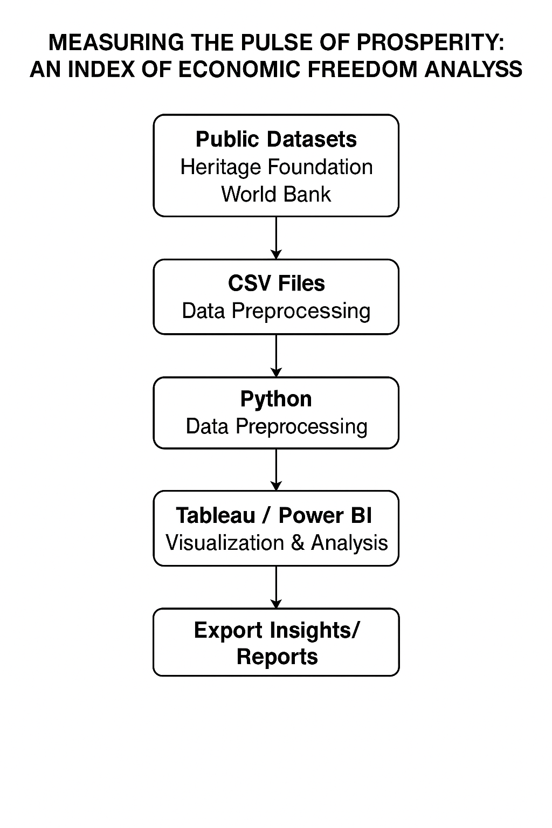

**Table-1 : Components & Technologies:**

|  |  |  |  |
| --- | --- | --- | --- |
| **S.No** | **Component** | **Description** | **Technology** |
| **1.** | **User Interface** | **How users interact with the system** | **Tableau Public / Power BI Web Dashboards** |
| **2.** | **Application Logic-1** | **Data preprocessing pipeline** | **Python (pandas, numpy)** |
| **3.** | **Application Logic-2** | **Correlation and statistical logic** | **Python (SciPy, statsmodels)** |
| **4.** | **Dashboard/Story Logic** | **Visualization & interactive logic** | **Tableau Filters, Parameters, Actions / Power BI DAX** |
| **5.** | **Data Source** | **Source of structured data** | **CSV datasets from Heritage Foundation, World Bank** |
| **6.** | **File Storage** | **Hosted data platform (if any)** | **Google Drive / GitHub for dataset hosting** |

**Table-2: Application Characteristics:**

|  |  |  |  |
| --- | --- | --- | --- |
| **S.No** | **Characteristics** | **Description** | **Technology** |
| **1.** | **Open-Source Frameworks** | **Frameworks for analytics and visualization** | **Python, Tableau Public, Power BI** |
| **2.** | **Security Implementations** | **Basic file access control, secure sharing of data and dashboards** | **Google Drive Permissions, Power BI Access** |
| **3.** | **Scalable Architecture** | **Cloud dashboards enable scalable sharing and embedding** | **Tableau Public / Power BI Cloud** |
| **4.** | **Availability** | **Dashboards can be published and available 24/7** | **Tableau Public / Power BI Service** |
| **5** | **Performance** | **Optimized data queries, dashboard filters, fast rendering visualizations** | **Tableau Public / Power BI Service** |

**References:**

[**https://c4model.com/**](https://c4model.com/)[**https://developer.ibm.com/patterns/online-order-processing-system-during-pandemic/**](https://developer.ibm.com/patterns/online-order-processing-system-during-pandemic/)[**https://www.ibm.com/cloud/architecture**](https://www.ibm.com/cloud/architecture)[**https://aws.amazon.com/architecture**](https://aws.amazon.com/architecture)[**https://medium.com/the-internal-startup/how-to-draw-useful-technical-architecture-diagrams-2d20c9fda90d**](https://medium.com/the-internal-startup/how-to-draw-useful-technical-architecture-diagrams-2d20c9fda90d)

# 4. PROJECT DESIGN

## 4.1 Problem Solution Fit

**🔍 Problem – Solution Fit Overview**

**🔻 Problem:**

Policymakers, researchers, and economists struggle to compare economic freedom across countries in a meaningful, interactive, and visual way. Static reports and raw data formats make it difficult to identify patterns or correlations between freedom indices and prosperity indicators such as GDP per capita or HDI. As a result, strategic policy insights are underutilized.

**✅ Solution:**

This project uses Tableau dashboards powered by cleaned and analyzed economic data (from sources like the Heritage Foundation and World Bank) to provide interactive visualizations that explore how economic freedom impacts national prosperity. Users can filter, compare, and download insights for deeper policy or academic decision-making.

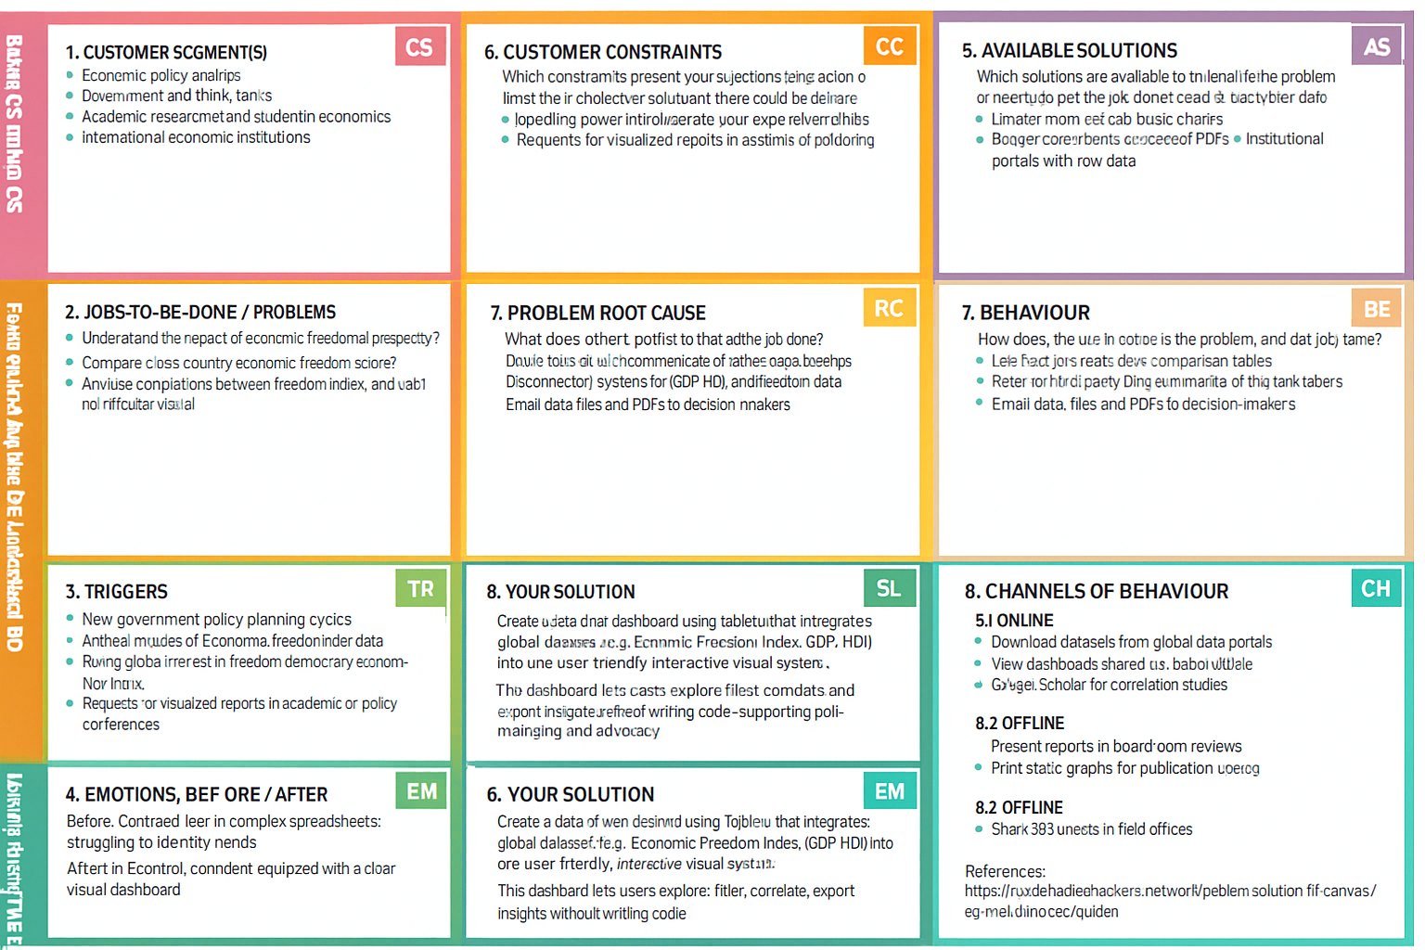**Template:**

References:

1. <https://www.ideahackers.network/problem-solution-fit-canvas/>
2. <https://medium.com/@epicantus/problem-solution-fit-canvas-aa3dd59cb4fe>

## 4.2 Proposed Solution

Project team shall fill the following information in the proposed solution template.

|  |  |  |
| --- | --- | --- |
| **S.No.** | **Parameter** | **Description** |
|  | Problem Statement (Problem to be solved) | Despite the existence of multiple economic indicators, there is no consolidated, transparent, and interactive platform that allows policymakers, researchers, and citizens to understand economic freedom and its role in prosperity. Data is fragmented, poorly visualized, and often outdated, limiting data-driven reforms. |
|  | Idea / Solution description | The project proposes designing and implementing a robust Economic Freedom Index, combining multiple dimensions of economic freedom into a single, explainable metric. Using modern data pipelines, advanced analytics, and interactive dashboards, the system will empower stakeholders to monitor and improve prosperity. |
|  | Novelty / Uniqueness | Unlike static economic reports, this solution will deliver dynamic, regularly updated, interactive, and transparent measurements of economic freedom, based on reproducible methodologies and open data sources. It will combine cutting-edge cloud technologies, advanced analytics, and modern visualization techniques. |
|  | Social Impact / Customer Satisfaction | By improving awareness of economic freedom and its drivers, the project promotes evidence-based reforms to support equitable growth, reduce poverty, and encourage investment. The public, policymakers, and researchers will have a trusted tool to monitor and compare prosperity drivers across regions and over time. |
|  | Business Model (Revenue Model) | The solution can be provided as a Software-as-a-Service (SaaS) platform for governments, think tanks, and universities. Premium versions could offer advanced analytics, predictive models, or consulting support, while a free public version can deliver simplified dashboards to maximize societal benefit. |
|  | Scalability of the Solution | The solution is designed to be highly scalable through a cloud-based architecture, supporting additional indicators, new regions, and larger volumes of data. Its modular architecture allows easy integration of future datasets, new scoring methodologies, and additional visualization features without major rework. |

## 4.3 Solution Architecture

**Solution Architecture:**

Solution architecture is a structured discipline that aligns business objectives with technology capabilities to address complex problems effectively. In this project, the solution architecture provides a blueprint for building a transparent, reliable, and scalable system to measure and analyze economic freedom as a driver of prosperity.

The architecture covers the complete flow — from data collection to insight generation — to ensure the Economic Freedom Index is accurate, reproducible, and meaningful for policymakers and researchers.

**Architecture Components**

**1. Data Sources**

* Primary economic indicators (GDP, regulatory burden, tax freedom, property rights, trade freedom, etc.)
* Publicly available databases (World Bank, IMF, OECD, Heritage Foundation)
* National statistical agencies

**2. Data Ingestion**

* Automated ETL (Extract, Transform, Load) pipelines built using tools like Apache Airflow, Talend, or custom Python scripts
* Scheduled data refresh to ensure consistency and up-to-date information

**3. Data Storage**

* Cloud-based data warehouse solutions (AWS Redshift, Google BigQuery, or Azure Synapse)
* Structured schema supporting efficient querying, secure storage, and scalability

**4. Data Processing & Transformation**

* Data cleaning: remove inconsistencies, handle missing values, and standardize indicators
* Data enrichment: apply weights, normalization, and scoring to build the Economic Freedom Index
* Feature engineering: design derived metrics for deeper insights

**5. Analytics Layer**

* Statistical modeling (regressions, clustering)
* Machine learning algorithms (trend detection, anomaly detection)
* Time series analysis for forecasting prosperity scores

**6. Visualization & Reporting**

* Interactive dashboards using Power BI, Tableau, or Plotly Dash
* Custom reporting APIs to deliver machine-readable data for policy tools
* Charts, heat maps, rankings, and time series views

**7. Stakeholder Access & Security**

* Web portal for policymakers and analysts
* Role-based access control to protect sensitive data
* Audit trails for data integrity and compliance

**Development Phases**

✅ Phase 1: Requirements gathering and stakeholder interviews  
✅ Phase 2: Design of data pipelines and schema  
✅ Phase 3: Data acquisition and transformation  
✅ Phase 4: Index modeling and scoring logic  
✅ Phase 5: Visualization and dashboard building  
✅ Phase 6: User testing, final deployment, and knowledge transfer

**Key Benefits**

✅ Transparent and explainable index methodology  
✅ Scalable and automated updates for long-term sustainability  
✅ Actionable insights through advanced visualizations  
✅ Better decision-making for economic reform initiatives

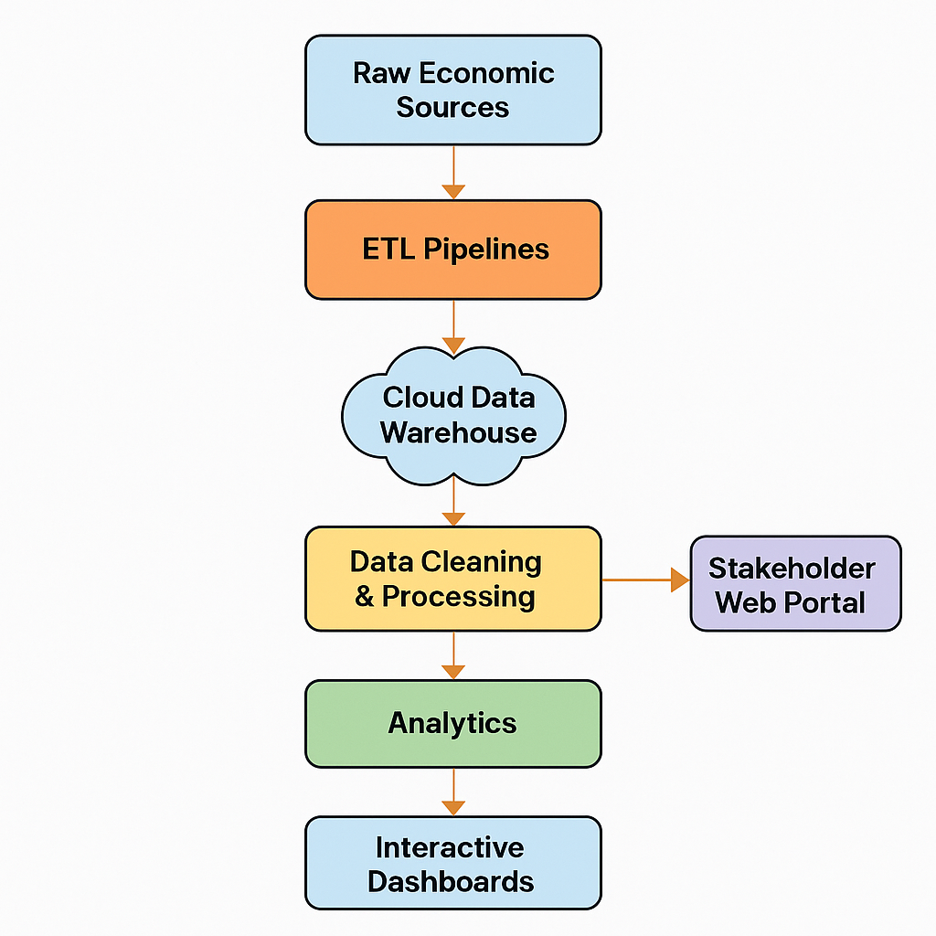**Solution Data Flow Diagram :**

**Figure 1:** Solution Data Flow Diagram for Measuring the Pulse of Prosperity Project

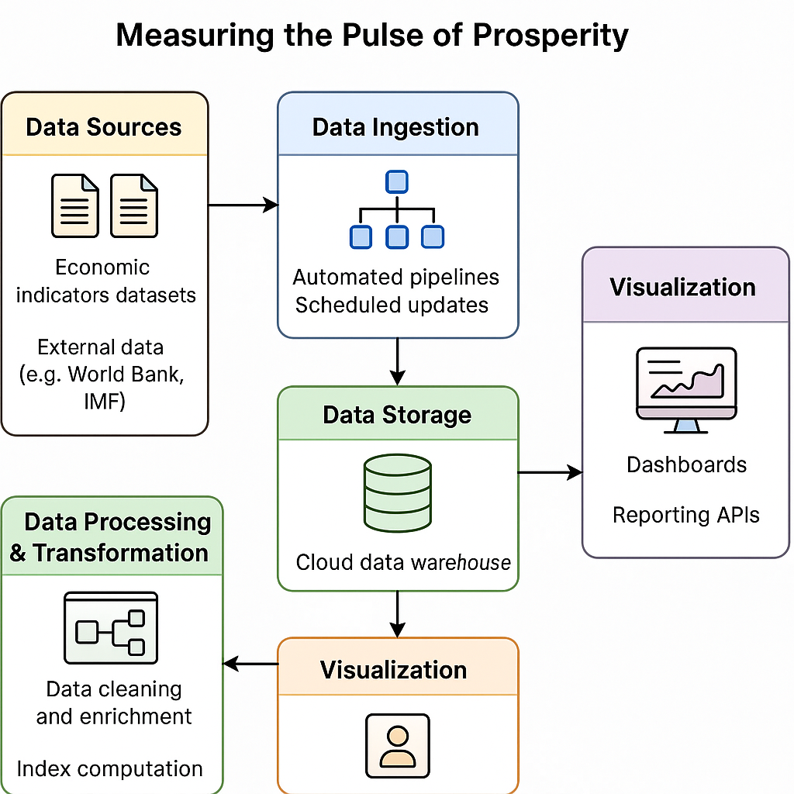**Example - Solution Architecture Diagram:**

**Figure 2:** Solution Architecture Diagram for Measuring the Pulse of Prosperity Project

**Reference:** [**https://aws.amazon.com/blogs/industries/voice-applications-in-clinical-research-powered-by-ai-on-aws-part-1-architecture-and-design-considerations/**](https://aws.amazon.com/blogs/industries/voice-applications-in-clinical-research-powered-by-ai-on-aws-part-1-architecture-and-design-considerations/)

# 5. PROJECT PLANNING & SCHEDULING

## 5.1 Project Planning

# 6. FUNCTIONAL AND PERFORMANCE TESTING

## 6.1 Performance Testing

**Model Performance Testing:**

Project team shall fill the following information in model performance testing template.

|  |  |  |
| --- | --- | --- |
| **S.**  **No.** | **Parameter** | **Screenshot / Values** |
|  | Data Rendered | Dataset includes multiple countries and their Economic Freedom indicators like Business Freedom, Trade Freedom, Fiscal Health, Government Integrity, and Overall Index Score. |
|  | Data Preprocessing | Missing values handled through filtering; country names standardized; year field extracted where necessary; calculated fields like “Average Index” or “Category Rank” created. |
| 3. | Utilization of Filters | |  | | --- | |  | |  |   Filters added for:  • Inflation rate in different countries • Region  • Economic Freedom Score Range  • Specific Indicators (checkbox or dropdown) |
| 4. | Calculation fields Used | • Inflation range from >=10% to 122  • Bottom Ranking countries in the index • Top 40 Ranking Countries in the index |
| 5. | Dashboard design | No of Visualizations / Graphs – 11   * 2022 Economic Freedom Score * Top 40 Ranking Countries in the index * Bottom ranking Countries in the index * Index Score based on unemployment Rate * Index Score based on Financial Problem * Index Score based on 5 year on GDP Growth rate(%) * Inflation rate in different countries * Correlation between inflation and unemployment * Correlation between GDP(PPP) and Monetary Freedom * Top 40 countries by GDP Growth rate |
| 6 | Story Design | No of Visualizations / Graphs -11   * 2022 Economic Freedom Score * Top 40 Ranking Countries in the index * Bottom ranking Countries in the index * Index Score based on unemployment Rate * Index Score based on Financial Problem * Index Score based on 5 year on GDP Growth rate(%) * Inflation rate in different countries * Correlation between inflation and unemployment * Correlation between GDP(PPP) and Monetary Freedom * Top 40 countries by GDP Growth rate |

# 7. RESULTS

## 7.1 Output Screenshots

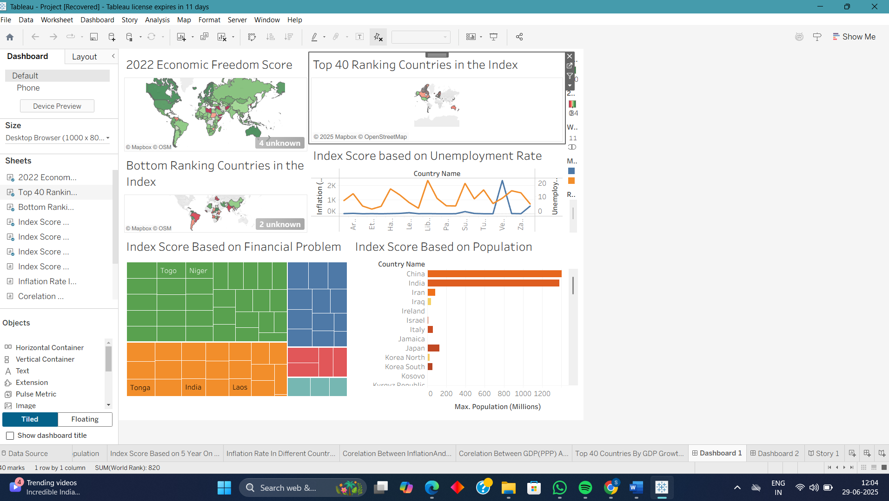

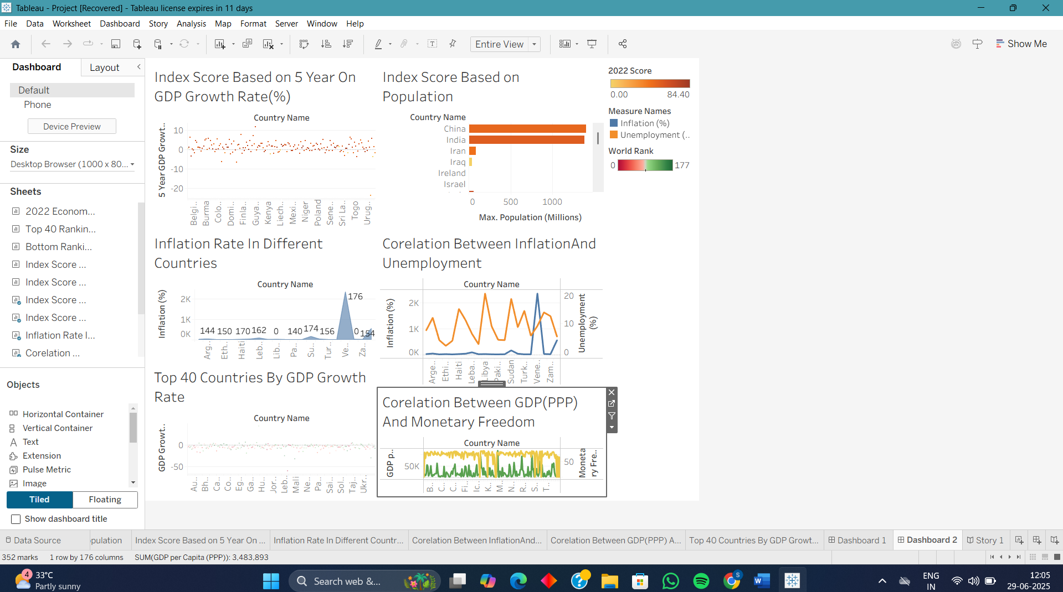

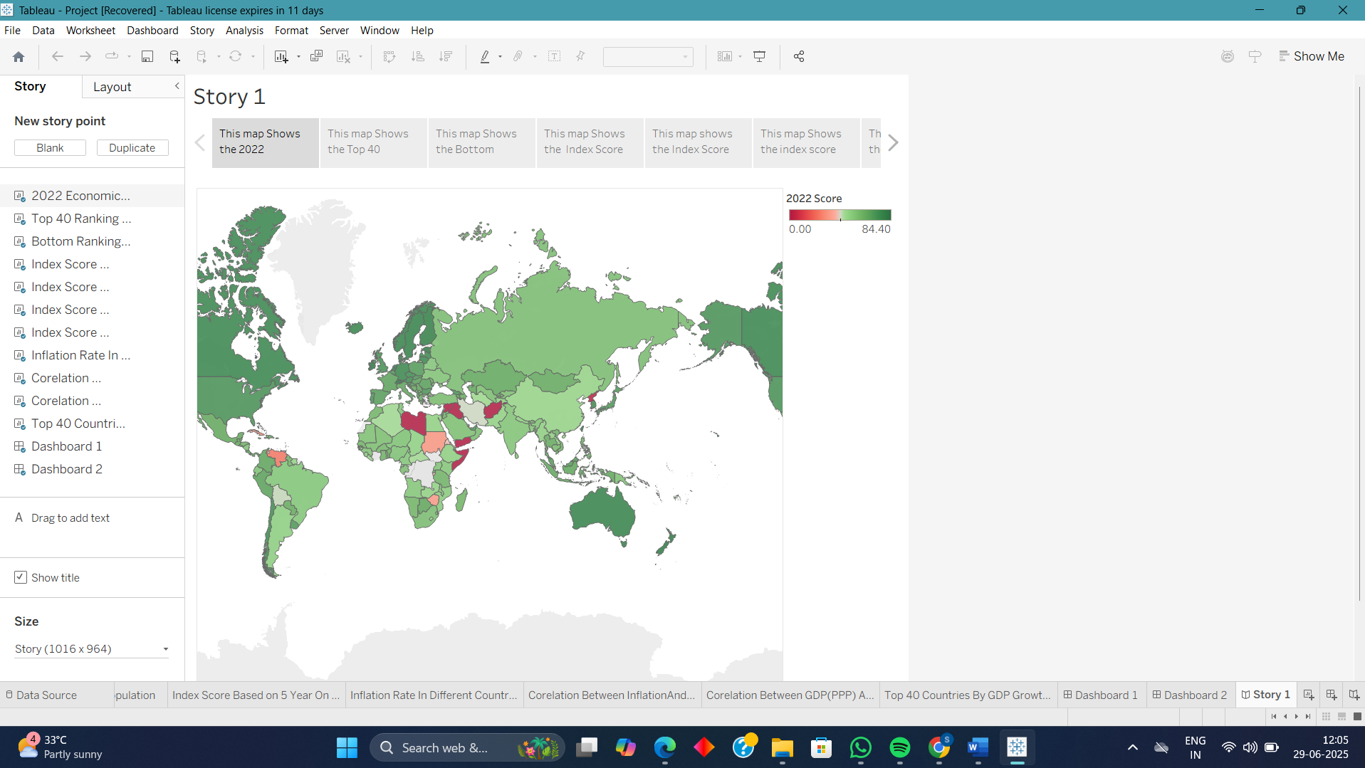

# 8. ADVANTAGES & DISADVANTAGES

• ✅ **Data-Driven Insights**: Provides a factual, evidence-based understanding of economic freedom across regions.

• ✅ **Interactive Visualizations**: Dashboards created using tools like Tableau make complex data easily understandable and accessible.

• ✅ **Multi-Dimensional Analysis**: Combines various economic indicators (e.g., tax burden, trade freedom, property rights) into a single, comprehensive index.

• ✅ **Supports Policy and Investment Decisions**: Helps governments, NGOs, and investors identify areas with growth potential or need for reform.

• ✅ **Promotes Awareness**: Educates stakeholders about the importance of economic freedom in driving prosperity.

• ❌ **Data Availability and Quality**: Inconsistent or missing data from some regions may impact accuracy and completeness.

• ❌ **Subjectivity in Indicator Weighting**: The selection and weighting of indicators could introduce bias or misrepresentation if not handled carefully.

• ❌ **Dynamic Nature of Economies**: Economic conditions change rapidly, requiring frequent updates to remain relevant and reliable.

• ❌ **Limited Contextual Interpretation**: High or low index scores may not fully reflect on-the-ground socio-political realities.

# 9. CONCLUSION

The project **"Measuring the Pulse of Prosperity: An Index of Economic Freedom"** successfully demonstrates the critical link between economic freedom and national prosperity. By integrating diverse economic indicators into a unified index, the project offers a clear, visual representation of how countries or regions perform in terms of fiscal health, business freedom, government transparency, and trade openness.

Through data analytics and interactive dashboards, this project enables a more informed evaluation of economic policies and their real-world impact. It empowers stakeholders—policymakers, researchers, and investors—with actionable insights to identify strengths, address weaknesses, and foster environments conducive to sustainable growth and development.

Ultimately, the project underscores that enhancing economic freedom is not just a policy goal but a pathway to improving the quality of life and long-term economic success of a nation.

# 10. FUTURE SCOPE

• 🔄 **Real-Time Data Integration**: Incorporating APIs and automated pipelines to fetch the latest economic data can make the index dynamic and constantly up-to-date.

• 🌍 **Geographical Expansion**: The project can be extended to cover more countries, regions, or even states and cities for localized analysis.

• 📊 **Advanced Predictive Modeling**: Machine learning algorithms can be used to forecast economic trends based on historical data and changing indicators.

• 🧠 **Incorporation of Social Indicators**: Integrating social dimensions like education, healthcare, and equality can offer a more holistic view of prosperity.

• 📱 **Mobile Dashboard Version**: Creating a responsive mobile app or platform to enhance accessibility for policymakers, students, and the public.

• 🤝 **Collaboration with Policy Institutions**: Partnering with think tanks or government bodies to influence data-driven policymaking based on the index.

# 11. APPENDIX

Dataset Link: https://drive.google.com/file/d/1EBIa1LtM3Ni2Uh3nekLB6wt3263Q3NeX/view

GitHub Link: https://github.com/SatishKumar877/Measuring-The-Pulse-of-Prosperity-An-Index-Of-Economic-Freedom

Project Demo Link: https://drive.google.com/file/d/16huOHTVm568Lx3ZiPn7qkcsFgNY9MZtW/view?usp=sharing